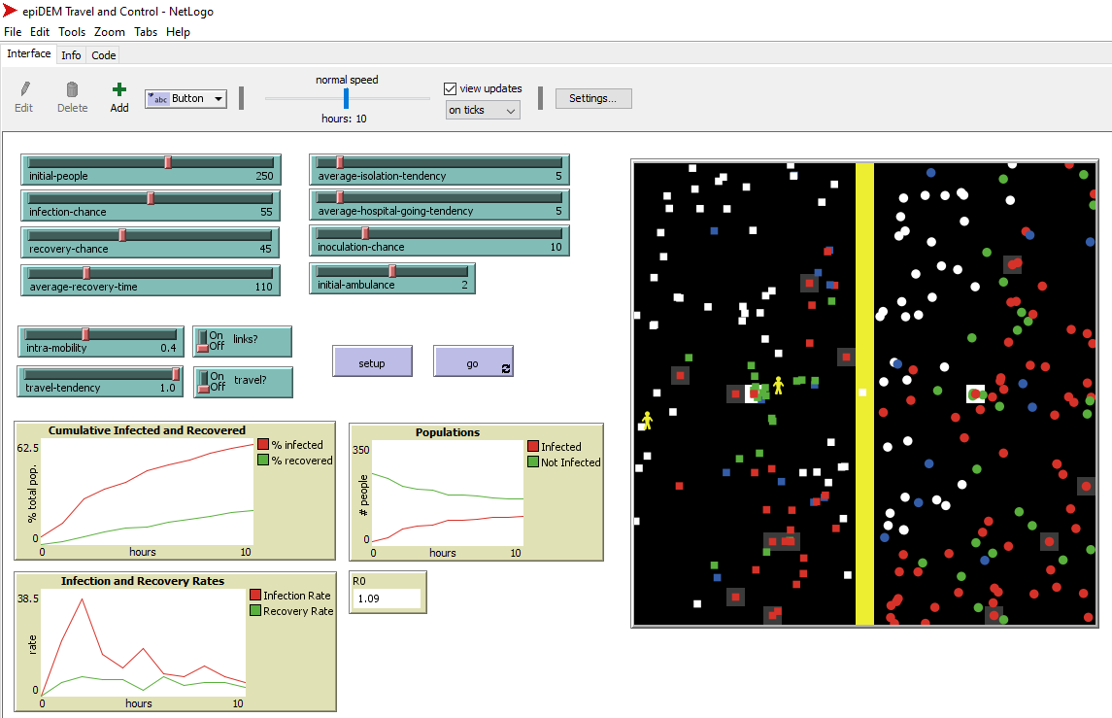

This figure is a multi-agent simulation platform that simulates the spread of infectious disease. Individuals will move in a random motion and spread the virus through contact with infected individuals. Each individual will have a status regarding the presence of the virus:

* White represents the uninfected individuals
* Red represents the infected individuals
* Green represents the recovered individuals who permanently immune to the virus
* Blue represents the individuals that have received the vaccine before
* Yellow represents the medical personnel that will send the infected individuals into the hospital when they come in contact

There are two regions in the simulation divided by a yellow border. Individuals from each region differentiated based on their shape (circle and square). Individuals will not cross the border unless we allow them to migrate or mix. Relations may be assigned randomly between individuals, thus making the virus spread twice faster to those that infected person is related. Individuals will have a tendency to go to the hospital or do self-isolation once they are infected. Infected individuals with a gray square around it, is the one who currently does self-isolation and infected individuals with a white square around it, is the one who currently is in the hospital. Infection chance, recovery chance, average recovery time, and people population is also something that we can set in this simulation. The output will show the status of infected and not infected (including recovered) individuals in number and a cumulative percentage per time.

Citation :

Yang, C. and Wilensky, U. (2011). NetLogo epiDEM Travel and Control model. http://ccl.northwestern.edu/netlogo/models/epiDEMTravelandControl. Center for Connected Learning and Computer-Based Modeling, Northwestern University, Evanston, IL.

Wilensky, U. (1999). NetLogo. http://ccl.northwestern.edu/netlogo/. Center for Connected Learning and Computer-Based Modeling, Northwestern University, Evanston, IL.